CLIENT NAME HERE
Intune - Using the Intune Autodeploy Method to Provision Machines

PREPARED BY
Kelvin Aruin – Senior Technical Project Engineer

TABLE OF CONTENTS
Pre-Requisites 3
Initiate the Out of Box Experience on the Device 4

Pre-Requisites
- Devices must be running Windows 11/10 build 1607 or later
- Devices must be running Windows Pro, Enterprise, Pro Education, or Pro Enterprise
- The device must have more than 30GB of free space
- Valid local and domain system credentials are needed to log on to the machine

Initiate the Out of Box Experience on the Device
- Power on the device
- Log on to the device with the local administrator credentials you gathered before starting this process
- Press the Windows Key + R together to open the Run box:
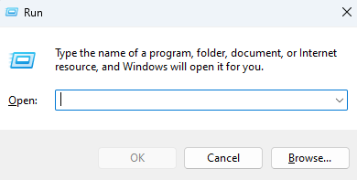
- Type the following command into the Run box:
“C:\Windows\System32\Sysprep\Sysprep.exe /oobe /reboot”
- Once the command is entered into the Open: field in the Run box, press the ‘OK’ button
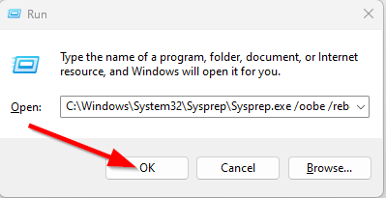
- The system will now reboot

Initiate Provisioning via Autopilot
- Connect the device to power
- Connect the device to an ethernet switch, wireless is not sufficient
- Power on the device
- Once the device boots up, you will be presented with the following prompt:
- Select the middle option “Pre-provision with Windows Autopilot”
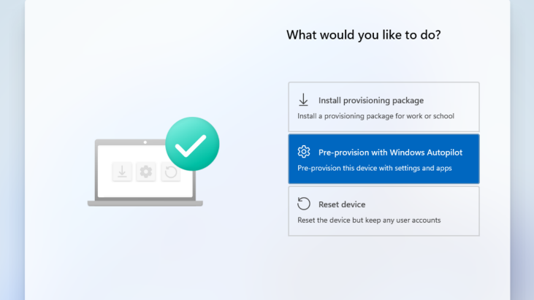
- The device should now begin configuration, and you will see the following:
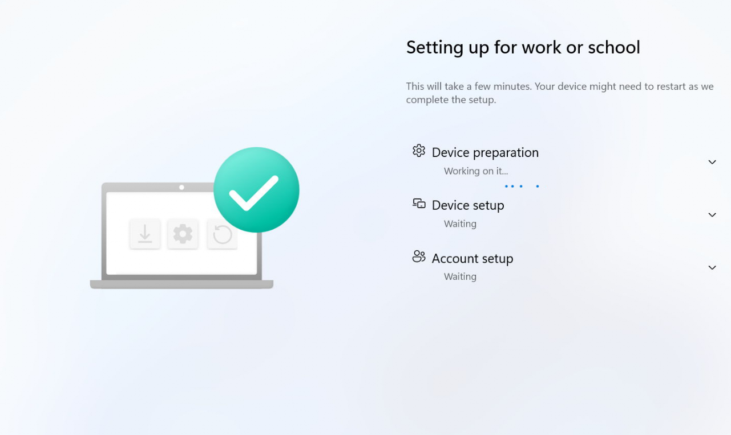
- Once the Device setup and the device process completes, the Windows Autopilot self-deploying deployment is complete, and the Windows sign-on screen appears

Final Entra ID Join and User Configuration
- Sign in with the pre-provisioned ImpactLocal account on the device (the account password should be in IT Glue under Passwords)

- Once logged in, open Settings, then Accounts, then Access work or school
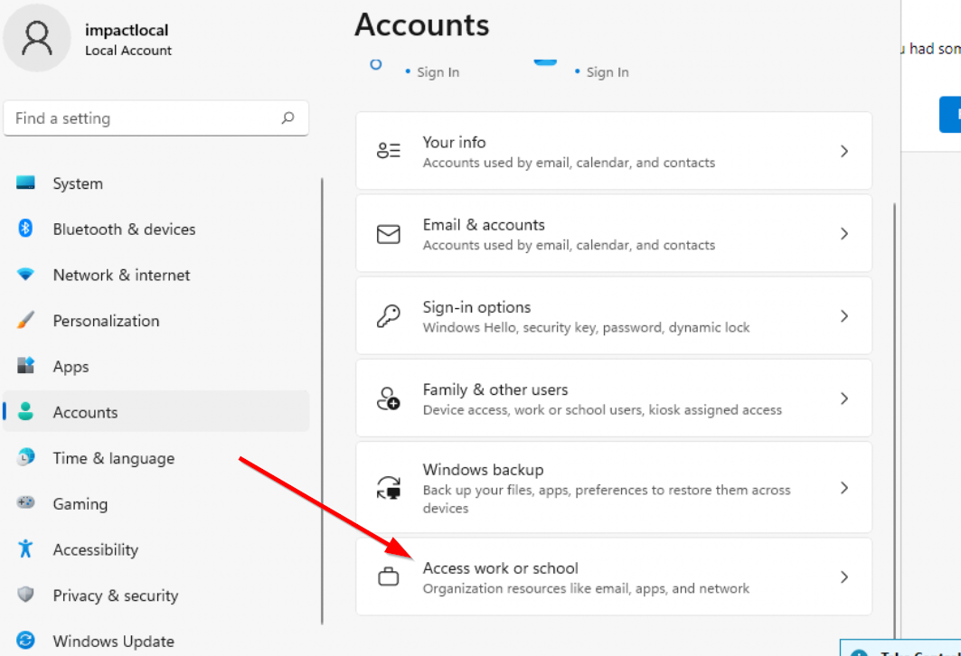
- Press the blue Connect button at the top of the screen:
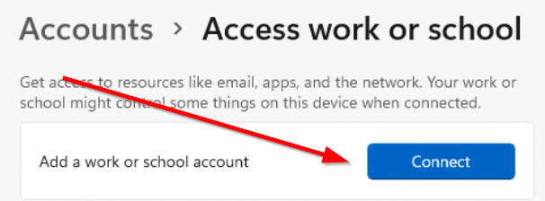
- On the next screen, make sure you don’t fill out the field but instead click on the “Join this device to Microsoft Entra ID” link at the bottom of the page:
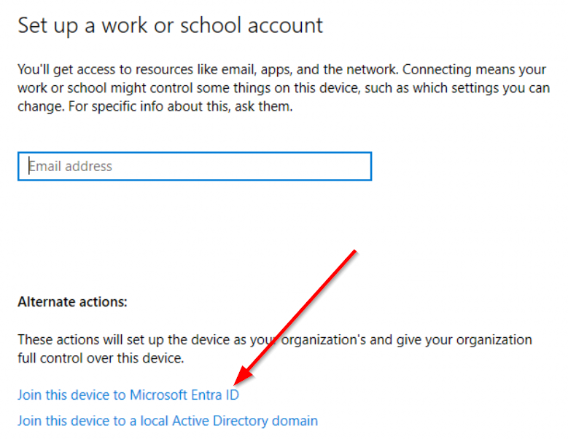
- Login with the user O365 account (You can use the impact account as well, but the user account is preferred).
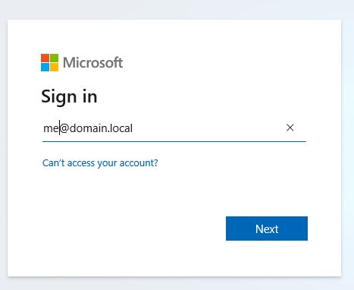
- If you did everything correctly, you will be prompted with this final screen:
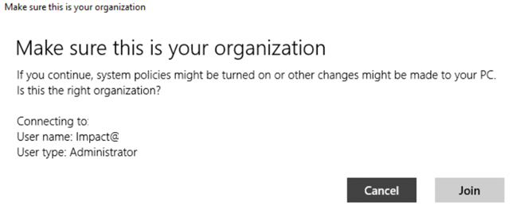
- Press the join button
- You should see the following screen when the process is completed:
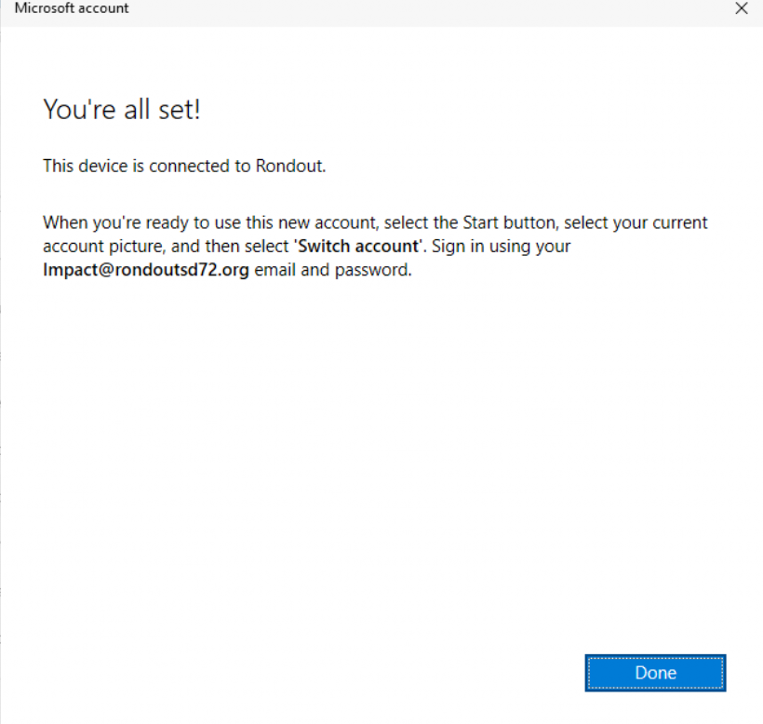
- Sign out of the local admin account
- The user can now log in with their O365 account
- Note: Intune will be deploying settings and applications now, so the device may restart and need time to be fully operational (about 30 minutes usually).

